Project Documentation

Project Title

# Introduction

## Project Title:cook book:your virtual kitchen assistant

* + **Team ID:NM2025TMID47711**
  + **Team Leader:** kaviyaG &Kaviyakaviya2007g@gmail.com

## Team Members:

## [karthikaG&gunakarthika0509@gmail.com](mailto:karthikaG&gunakarthika0509@gmail.com)

## [kanmaniJ&kannujayaprakash@gmail.com](mailto:kanmaniJ&kannujayaprakash@gmail.com)

## Kanishkav&kanivetrikani2007@gmail.com

# Project Overview

* + **Purpose:** SB Works connects clients and freelancers through project postings, bidding, and real-time communication.

## Features:

* + - Project posting and bidding
    - Secure chat system
    - Feedback and review system
    - Admin control panel

# Architecture

* + **Frontend:** React.js with Bootstrap and Material UI
  + **Backend:** Node.js and Express.js managing server logic and API endpoints
  + **Database:** MongoDB stores user data, project information, applications, and chat messages

# Setup Instructions

## Prerequisites:

* + - Node.js
    - MongoDB
    - Git
    - React.js
    - Express.js **–** Mongoose **–** Visual Studio Code

## Installation Steps:

# Clone the repository git clone

# Install client dependencies cd client npm install

# Install server dependencies cd

../server npm install

# Folder Structure

SB-Works/

|-- client/ # React frontend

| components/ L pages/

| server/ # Node.js backend

| routes/

| models/

| controllers/

# Running the Application

## Frontend:

cd client npm start • **Backend:**

cd server npm start

* + **Access:** Visit http://localhost:3000

# API Documentation

## User:

* + - /api/user/register
    - /api/user/login

## Projects:

* + **Chats:**
* /api/projects/create
* /api/projects/:id • **Applications:** /api/apply
* /api/chat/send
* /api/chat/:userId

# Authentication

* + JWT-based authentication for secure login
  + Middleware protects private routes

# User Interface

* + Landing Page
  + Freelancer Dashboard
  + Admin Panel
  + Project Details Page

# Testing

* + Manual testing during milestones
  + Tools: Postman, Chrome Dev Tools

1. Screenshrot on demo

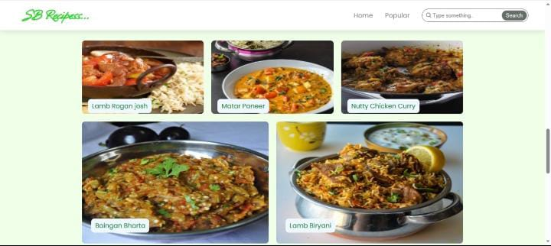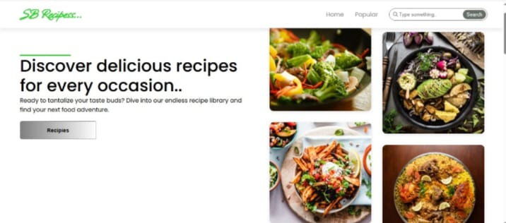

1. **Known Issues**

**Certain API end points may experience delays peak traffic ingredient check list feature may require further optimization**

1. **Future Enhancements**

* **AI based recipe suggestions**
* **User authentication for personalized recipe collection**
* **Integration with grocery shopping platforms**
* **Offline mode for accessing saved recipes**